Name: Gismi Antony Roll No:76

GOOD UI DESIGN

1. Medium

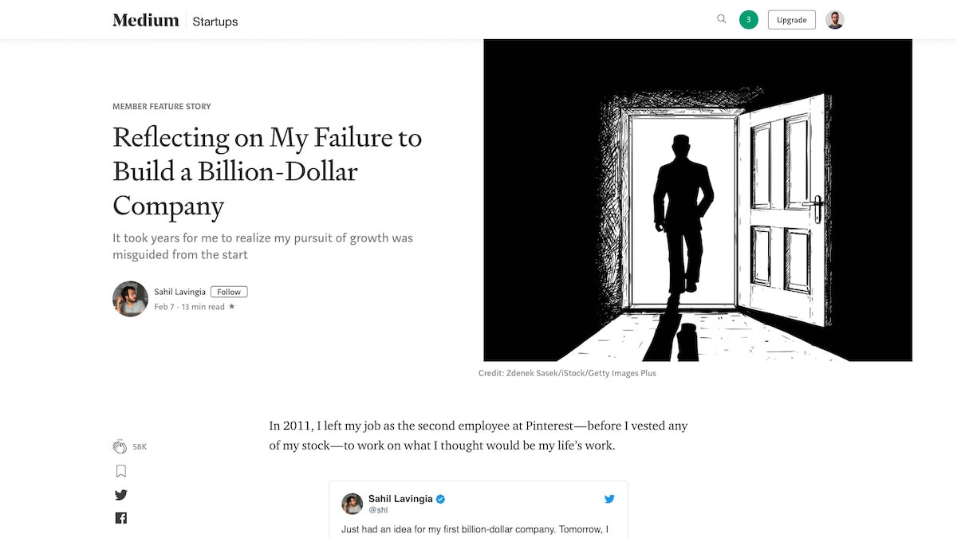

Medium, an online reading and publishing platform, is just as gorgeous as it is functional. With minimal use of [color](https://careerfoundry.com/en/blog/ui-design/introduction-to-color-theory-and-color-palettes/), generous line spacing, and a well chosen combination of [typography](https://careerfoundry.com/en/blog/ui-design/beginners-guide-to-typography/), this website gets everything right.

With Medium, content is king. Once a user is logged in, a box appears at the top of the article list with the text “Write here”, enabling and encouraging everyone to get writing quickly. When users click on the “Write a Story” link, they are presented with an almost empty white page, removing clutter and simply providing a clean space to focus on writing.

Articles are set up in a one column format, making content easy to digest. With little touches like estimated read time and the ability to highlight and respond directly to specific pieces of articles, Medium truly provides users with an amazing and effortless editorial experience.

## Spotify’s color gradients

## It’s no secret that color gradients are becoming ever more favored by UI designers over flat colors. Powerful when used intentionally, color gradients are a go-to when the need to convey emotions or highlight a certain design element arises.

## Spotify's iconic color gradient

## Bad UI Design

### Typesetdesign

The background color and text color are pretty much similar, leaving a very weak contrast. The poor contrast makes the text become blurry to the eye. Besides, the small font size makes the readability of the text extremely poor.

### The design lacks contrast

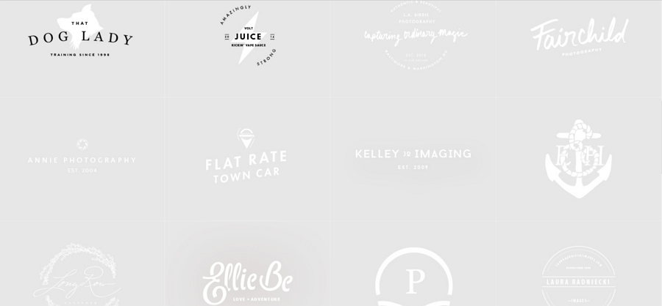

1. University of Advancing Technology

It offers a challenging curriculum. But, to find a course you must first take this eye-test of a multi-layered flyout submenu, in tiny gray text over a black background on [their website](https://www.uat.edu/). There is Difficulty of navigation.

